Cayuga Lake Monitoring Partnership
Comments Document
For the draft Total Maximum Daily Load for Phosphorus in Cayuga Lake
6-24-2021

Table of Contents
Comments in order of TMDL Section: 3
Section 1 Introduction 3
Section 1.2 Problem Statement 3
Section 1.2.1 Scope of Water body/Segment Impairment 3
Section 1.2.2 Scope of Unimpaired Segments 4
Section 2 Watershed and Lake Characterization 4
Section 2.1: Watershed Characterization 4
Sections 2.1.1-2.1.3 Segment Designations 6
Section 2.2 Lake Morphometry 6
Section 2.3 Water Quality 6
Section 2.3.1 Cayuga Lake Modeling (CLM) Project 6
Section 2.3.2 CU LSC and Other WQ Monitoring Programs 7
Section 2.3.3 Historical WQ for the Southern End and Main Lake, Mid-South segments 7
Section 3 Numeric Water Quality Target 8
Section 4 Assessment of Sources 9
Section 4.1 Analysis of Total Phosphorus (TP) Contributions 9
Section 4.1.1 Agricultural Sources 9
Section 4.1.2 Developed Land 10
Section 4.1.3 Forested Lands and Wetlands 10
Section 4.1.4 Residential and On-Site Septic systems 10
Section 4.1.5.1 Wastewater Treatment Facilities 11
Section 4.1.6.1 Internal Loading/Recycling 11
Section 5 Phosphorus Loading Capacity Analysis 11
Section 5.1.1 Lake Modeling Using the Cayuga Lake Model (CLM) 11
Section 5.2 Cayuga Lake Model to Determine Loading Capacity 11
Section 5.3 CLM Scenario Results to Achieve Water Quality Targets 12
Section 6 TMDL Load Allocations 12
Section 6.1 Impaired Segment Overview of Load and Waste Load Allocations and Load Reductions 12
Section 6.3 12
Section 6.4 Unimpaired Segments overview of Load and Waste Load Allocations and Load Reductions 13
Section 6.7 Margin of Safety 13
Section 6.10 Reasonable Assurance 13
Section 7 Implementation Section 14
Section 7.1 Summary 14
Section 7.2 Sub-Basin Relative Loading Characteristics 15
Section 7.4.2 Lake Source Cooling 17
Section 7.4.5 NYS Dishwasher Detergent and Nutrient Runoff Law 17
Section 7.7 18
Section 7.7.2 18
Monitoring Plan 18
Section 7.8.2 Forestry Conservation Practices 18
Section 7.9.6 19
Section 8 Public Participation 19
Appendix G 20
Comments, Questions and Discussion points grouped by TMDL Themes: 21
TP and SRP Loading: 22
Opportunities 23
Municipal: WWTF, MS4s, Construction General Permit and Forestry 23
Source Water Threat: 28
Streams: 29
Wetlands: 30
References: 31

Comments in order of TMDL Section:
Comments are italicized.
Citations are listed at the end of the comment document.

Section 1 Introduction
- DATA VS. DATUM “Data” is the plural version of the singular “datum.” In a sentence, “data” is always treated as a plural noun. Please correct the verb usage throughout the document.

Section 1.2 Problem Statement:
Document states, “Over the past several decades, the lake has experienced degraded water quality that threatens source water quality and has reduced the lake’s recreational and aesthetic value.”

  - Cite your references.
  - This statement is not supported by Figures 8 and 9 (section 2.3.3) as they show both an increase in the early 2000s and a decrease since that time. Please review your conclusions.
  - As it is a phosphorus TMDL, phosphorus should be listed in the problem statement.
  - When will the sediment TMDL, 9E or other watershed management plan be developed?

Section 1.2.1 Scope of Water body/Segment Impairment:
The Cayuga Lake Watershed Intermunicipal Organization recently reaffirmed updating of the watershed map to include the section of the Seneca River that periodically flows southward into Cayuga Lake (based on lock position (open/closed) and hydropower releases). This area of the watershed was not historically included in any finger lake. In 2005, a USGS gage (04232730) was installed on the Seneca River just upstream of the route 89 bridge crossing. Data from that gage have changed our understanding of the water dynamics in the northern portion of Cayuga Lake (information from USGS can be provided upon request).

That portion of the Seneca River does indeed contribute water significantly into the Northern End segment of the lake and should be included in the official map of the area. Further, DEC included that portion of the watershed in their modeling (per the public information session on April 19th). Not including it in the map misrepresents the model and TMDL load calculations and will discourage participation in the TMDL from landowners in that area.

This section lists the towns that border the lake, but not the villages nor the City of Ithaca. The other counties in the watershed are listed, but not the other towns and villages that are in the watershed.

Table 1 Main Lake, Mid-South Classification includes “Drinking Water with limited treatment”, while under best uses, the description is, “This classification may be given to waters that, if subjected to approved disinfection treatment, with additional treatment, if necessary, to remove naturally present impurities, meet or will meet New York State Department of Health drinking water standards and are or will be considered safe and satisfactory for drinking water.”

  - Include the currently excluded small portion of the Seneca River section (referenced in Section 2.1) in the watershed description and all maps (starting with Figure 1) based on USGS data.
  - To be consistent, list all the municipalities in the watershed, noting which ones border the lake. A table with waterfront municipalities and counties indicated may serve the purpose better.
  - All portions of Cayuga Lake meet the drinking water standard as a source water as stated under the “Best Use” column of the table. Source waters for drinking water are presumed to require filtration and chlorination. The classification information is either inaccurate or inconsistent with the best use information. The classification statement should be corrected or updated to meet federal and state standards. This has ramifications for the subsequent statements regarding natural organic matter (NOM) in the document.

Section 1.2.2 Scope of Unimpaired Segments:
“The Main Lake, Mid-South and Main Lake, Mid-North segments of Cayuga Lake are currently threatened as a drinking water source due to algal (phytoplankton) biomass concentrations driven primarily by both external phosphorus loading to the lake (NYSDEC 2018) and internal phosphorus circulation.”

  - Cited source does not determine primary driver(s) of algal blooms. The certainty with which external phosphorus inputs have been shown to be a primary cause of HABs is overstated in the draft TMDL.
  - Cited source lists several drivers of algal blooms. All sources should be stated consistent with the current scientific understanding, or at least consistent with NYS’s own 2018 “Harmful Algal Bloom Action Plan Cayuga Lake.”
  - No Cayuga Lake segments are threatened as a drinking water source based on algal (phytoplankton) biomass. The recent advent of potentially harmful cyanobacterial blooms should not be conflated with general algal/phytoplankton biomass. Biomass is easily removed from source water and does not pose a threat to drinking water.

Section 2 Watershed and Lake Characterization
Section 2.1: Watershed Characterization
Watershed maps exclude the Seneca River portion of the watershed. The name, ‘Sixmile Creek’ has been changed, see the official letter below:
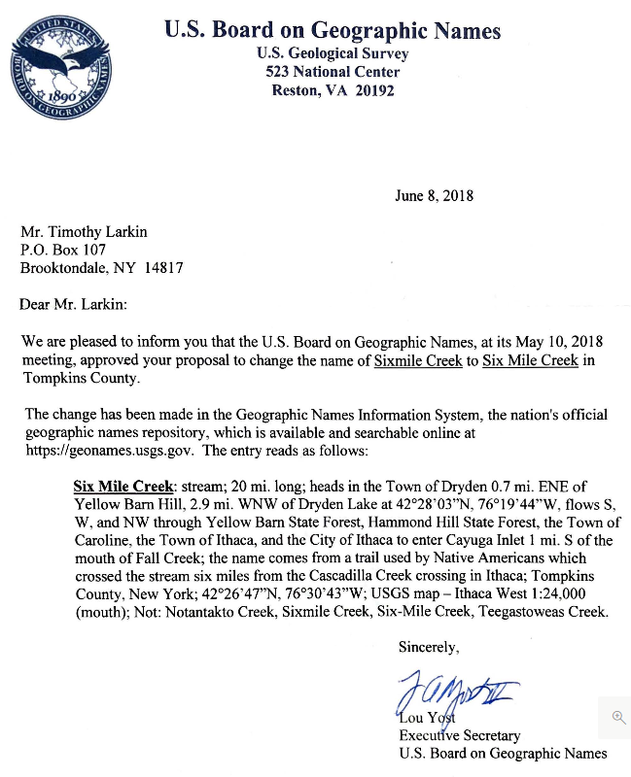

  - Include the Seneca River section in the watershed description and map (Figures 3 and 4) based on USGS data.
  - USGS updated the name of Six Mile Creek from Sixmile Creek in 2018. Please make corrections throughout the document.
  - Figure 3 - Map Delineating Cayuga Lake is too small, consider enlarging it so that details can be read.
  - Figure 3 - Cascadilla Creek should be added because it is referenced in the text.
Section 2.0 appears outdated to the casual reader because several years have passed since the water quality data were collected. New landcover information is available (2016) and some Counties may have even newer information. It is our understanding that the SWAT model does not treat landcover information as a changeable variable and that the 2011 landcover data are most relevant to the ‘pre-2013 data’ (water quality, precipitation, hydrology, etc.) that was used to calibrate the model. Further, that the 2013 water quality data were collected to validate the model.
Seven years have passed between collection of the validation data and release of the draft TMDL. More than four years have passed since DEC was in possession of all the data and associated models.
The following information may be best placed in the Monitoring Section, 7.7.2.
  - Please include a timeline for updating the model data (landcover, precipitation, hydrology, water quality, etc.) and rerunning the model to confirm appropriateness of suggested phosphorus reductions, assess progress towards TMDL goals, inform actions, and other relevant milestones.

  - Please list all TMDL milestones explicitly in the final TMDL.

Sections 2.1.1-2.1.3 Segment Designations
The text references the Towns of McKinneys and Coonley Corners, those towns do not exist. Additionally, the lake segments use obscure references to McKinneys Point and Coonley Corners Rd, which are not familiar to most people reading this.

  - Use geographic references that exist or include GPS coordinates for all sections.
  - If DEC chooses to use the historical location references, provide the historical map in the final TMDL along with corresponding location names.

Section 2.2 Lake Morphometry:
Paragraph two states, “There is complex and dynamic circulation between the Southern End and the main lake (Effler et al. 2010…)

  - Include the specific findings of the Effler 2010 report (referenced in the draft TMDL) that the southern end mixes with the main lake roughly every day. This point is critical in understanding that the southern end is never really a separate segment of the lake and supports the notion of a whole lake TMDL.

  - Expound more on the internal seiche and how climate change will only increase the mixing of the sections through intensified wind patterns, further making the southern end ‘segment’ an arbitrary designation that is not truly manageable or trackable as a separate entity from the main lake.

Section 2.3 Water Quality:

  - Add Community Science Institute to table of Water Quality Investigations in Cayuga Lake from 1970s-Present. Include the indicator that these data are collected under a DEC approved quality assurance project plan.

Section 2.3.1 Cayuga Lake Modeling (CLM) Project:
Paragraph two states, “The CLM Project data indicated that individual TP concentrations were greater than 20 µg/L at the Southern End (Sites 1-2) with summer average values also greater than 20 µg/L.” A major finding of the Cornell study was that P and sediment issues cannot be separated in this system.

  - The current science (CLM Project) suggests that the total phosphorus (TP) exceedances of 20ug/l guidance value in the southern end reflect large sediment loads into the area during events and are NOT strongly related to bioavailable P and algal blooms. This does not seem to be reflected in the draft TMDL.
  - Please review Effler et al. 2002 and Effler et al. 2010, both cited in the TMDL, for the full discussion of phosphorus inputs, inorganic tripton, chlorophyll a, and algae on the southern end of Cayuga Lake. Please pay extra attention to the suggested management approaches.
  - Please provide a table of the southern end TP data that led to the determination of exceedance of the narrative standard. Include a map of the sampling locations. Areas sampled in WWTP outfalls and stream mouths, such as those locations sampled in the Water Quality Study of the Finger Lakes (Callinan, 2001), are not valid sampling locations. Nor are samples collected in mixing zones or during runoff events. New York State’s Fact Sheet, “Ambient Water Quality Value for Protection of Recreational Uses” 10/22/1993 lists criteria for collection of TP samples including location. The location is mid-lake. Clearly in a lake as large as Cayuga Lake, there can be multiple ‘mid-lake’ sampling points, however, near shore, tributary inputs and mixing zones would not meet New York State’s own standards. Please provide information that shows the final interpretation of impairment does not include such data.

Section 2.3.2 CU LSC and Other WQ Monitoring Programs: Paragraph two states that TP and Chlorophyll-a (Chl-a) data collected in late 1990’s were indicative of oligo-mesotrophic lakes and data from the early 2000’s through 2012 (via citation in TMDL) indicated mesotrophic conditions.

Major WWTP upgrades to reduce phosphorus are referenced in the document but not followed up on with respect to impacts on water quality.

  - Summarize all the data shown in Figures 8 and 9 to reflect data from the period covering 2012 through 2018.
  - the text includes a reference to Figure 7, then the next sentence starts, “Several site” followed by an “OBJ.” The OBJ is missing.
The paper, Apportionment of Bioavailable Phosphorus Loads Entering Cayuga Lake, New York states that, “Point source contributions to the total bioavailable P load (BAP_{L}) are minor (5%), reflecting the benefit of reductions from recent treatment upgrades.” Prestigiacomo, et al., 2105.
  - Please comment on observed or expected water quality changes in the southern end of Cayuga Lake after the 2006 wastewater treatment upgrades. It is worth commenting on this important change in loading and will provide valuable insight into what can and cannot be expected from non-point source loading reductions.

Section 2.3.3 Historical WQ for the Southern End and Main Lake, Mid-South segments:

  - It is impressive that the model performed so well at predicting 2013 water quality as it was an unusual year. This shows that the model performs well even at the outer limits of expected parameters.
  - Error bars would assist the reader in understanding how this outlier year could be compared with other years.
  - Include water quality data tables for the Main Lake, Mid-North and Northern End segments.
  - Include summaries of water quality data from those lake segments in section 2.3.2.
  - Add sample sizes, error bars, and indicate whether all were surface samples or not for Figures 8 and 9 and the new Figures for Mid-North and North End segments.
  - Figure 9: Caption should read, “…(Bottom) the Main Lake, Mid-South…” not, “…(Bottom) the Southern End segment…”.
  - A casual comparison of the Summer Average TP and Summer Average Total Chlorophyll-a does not show a clear relationship between the two, especially for the model year 2013 Southern End – the TP is highest at 27.0 ug/L and the Chl-a is lower than most other years at 4.4 ug/L. Please address this apparent conflict with the presumed linkage of TP and Chl-a made throughout the TMDL.
  - Figure 9 Bottom graph – the 2018 value of 4.0 has an asterisk but there is no note to describe why.

Section 3 Numeric Water Quality Target
Table 10*(page 26) lists the Summer Average Total Chlorophyll-a Target for the Main Lake, Mid-South as 4 ug/L.
  - According to the bottom graph in Figure 9, Summer Average Total Chlorophyll-a has not been below 4 ug/L in 20 years. How realistic will it be for this segment to reach this target, especially when the segments on either side have higher targets and continually mix?
  - Section 2.3.3 and Section 3 – it would clarify the Summer Average Total Chlorophyll-a Target in Table 10 if Section 2.3.3 also included figures for Summer average TP and Summer Average Total Chlorophyll-a for the two northern segments.
  - *Table 10 appears again on page 43 but contains different information
    - Table 9 also appears twice, on pages 20 and 41. They are not the same tables. This duplication of Table numbers impacts MANY tables in the document. Please correct.
    - The table on page 40 is not labeled.
  - Table 10 implies the impairment is drinking water, not recreation. There is not now, nor has there ever been, a drinking water facility using the southern end of Cayuga Lake. There is also no reasonable expectation that the southern end of Cayuga Lake will ever need to be accessed for drinking water, at least not more so than the northern end, which is not currently designated as Class A. The classification information is already provided in Table 1 and does not need to be repeated in Table 10.
  - Clearly state in the document what impairment triggered development of this TMDL and provide supporting evidence.
    - This belongs in the problem statement
  - Clearly support how this TMDL will resolve the triggering impairment.
    - This belongs in Section 6 under ‘Reasonable Assurance’

Section 4 Assessment of Sources
Section 4.1 Analysis of Total Phosphorus (TP) Contributions:
Includes the four detailed tables of the TP loading for each segment.

- Consider a more realistic assessment of inputs, for example, section 2 does not include section 1 inputs – that is not possible.
Tables 11 and 12 include footnotes for MS4s, stating “MS4 loading is accounted for in the developed land load.” This is confusing because the MS4s include loading numbers that are much higher than the Developed Land loading.
  - It would be helpful to have a summary table so that the reader better understands this statement (just before Table 11): “Approximately 91% of the TP load to Cayuga Lake is from nonpoint sources and 9% from point sources.”
  - The footnote needs to be revised or the Developed Land loading needs to include the value in the MS4 line.
Tables 11-14 footnote states: Runoff from farm fields is accounted for in the nonpoint source agricultural load.

- It is unclear exactly how that is accounted for and if some or no reductions are expected from these lands. Please provide more information, particularly in the main body of the document. Please do not leave all explanation in the Appendices.

Section 4.1.1 Agricultural Sources:
As written here and elsewhere that CAFOs are mentioned, it is unclear how various land uses within a CAFO are addressed in the model. Discharge from CAFOs is assumed to be zero (0). In reality, this falls back to enforcement, weather, timing, labor/operator skill & follow-through, following the CNMP exactly, etc. This is an unrealistic presumption.

  - It appears that wineries (grape cultivation) and breweries (hops cultivation) are ignored in the TMDL. Please comment on how they were included and what reductions are being asked from those lands. If they were excluded, please provide a rationale, and explicitly state in the TMDL that they were excluded.
  - Please provide a summary of CAFO compliance records/performance over the last 7 years (time elapsed between model data collection and publication of the draft TMDL) to support the assertion that discharges will not exceed permitted amounts.
  - Clarify how CAFO land (owned and leased or otherwise operated), not the barnyard area, is handled in the analysis.
  - Where phosphorus reductions from agriculture are modeled, please Indicate how much comes from CAFOs and non-CAFO farms and from barn lot areas versus planted and cultivated areas.
  - Include the following as part of the TMDL compliance actions:
    - increase DEC oversight of CAFO compliance with their CNMPs,
    - increase DEC oversight with regards to rate of manure application, timing of manure application, and time between application and working land to incorporate manure, and
    - increase DEC enforcement beyond minimal response to complaints.

Section 4.1.2 Developed Land:
The last sentence of the one paragraph in this section states, “Shoreline development can have a large phosphorus loading impact to nearby waterbodies in comparison to its relatively small percentage of the total land area in the drainage basin.”

  - Add Cayuga Lake specific information (with citations) to the above statement such as percentage of shoreline developed, estimated number of septic systems, estimated loading, etc. Provide information that is informative about this specific watershed and will help guide actions.
Section 4.1.3 Forested Lands and Wetlands:
This is the text for the entire section, “Forested lands (including shrub and grassland) comprise 154,000 acres or approximately 30% of the Cayuga Lake drainage basin. Wetlands comprise an additional 23,000 acres or 5%. TP loading from forested lands and wetlands consists primarily of overland runoff.”
- What is the cause of overland phosphorus runoff? Is it caused during timber harvesting or general erosion from forested areas?
- Has DEC considered, or is there any research on the rather recent prevalence of European earthworms? They are causing erosion of the humic layer and leaving the highly erodible mineral soil. If that has been considered, what implementation actions does DEC recommend?
- What implementation actions does DEC recommend in general regarding forested lands and wetlands?
Section 4.1.4 Residential and On-Site Septic systems:
USEPA 2002 is used as a reference for assessing septic system functionality.
This section also states, “For a review of the septic analysis for the Cayuga Lake TMDL see Appendix F.”
  - Because Cayuga County has an inspection program, they will have more accurate data than the USEPA 2002 reference. Please use Cayuga County data that is more accurate and watershed specific.
  - Appendix F, Table F3 lists “Individual, Municipal and Private/Commercial/Institution (PCI) Permits within the Cayuga Lake watershed” but there is no analysis and no description of the permit classes. Please include a description of the permit classes and provide some analysis of the available data.
  - Septic loading contribution is set at 0.4% for all segments except the North End. Even given the limitations in available information this consistent percentage seems unlikely and needs further clarification as to how this was arrived at.

Section 4.1.5.1 Wastewater Treatment Facilities:
The first sentence states, “The following SPDES facilities are included in the Cayuga Lake TMDL because they likely have the greatest impact on Cayuga Lake water quality . . .”

  - How can that be true when the total phosphorus point source load is only 9%? This statement should be clarified.
  - Specify what the one industrial facility is that is mentioned on the third line of this section.

Section 4.1.6.1 Internal Loading/Recycling:

  - Suggest removing the first word, “According…”. It reads as though DEC is dubious of the CLM findings it commissioned, oversaw, and approved.
  - The first sentence implies that internal nutrient cycling is somehow harmful or unusual. All lakes experience internal nutrient cycling. What is DEC’s goal for this section?
  - The second paragraph seems to ignore the initial statement that Cayuga Lake does not experience internal TP loading. If the goal is to discuss legacy phosphorus, please change the terminology so the reader is not confused. Better yet, delete the second paragraph.
  - Please include a more complete discussion of the CLM project results regarding mussels in Cayuga Lake.
  - Results presented in Li, et al. 2021 show that internal phosphorus cycling is controlled by quagga mussels in the lower four Great Lakes. They also show that this diminishes the impact of phosphorus from the watersheds and has important implications for management. Please address this issue with respect to impacts on effectiveness of the dTMDL proposed BMPs.

Section 5 Phosphorus Loading Capacity Analysis
Section 5.1.1 Lake Modeling Using the Cayuga Lake Model (CLM):

  - Why is groundwater ignored in the model?
  - Table 15 –
    - Please add sample sizes, standard deviations (or similar), and indicate if all readings are surface readings.
    - Please provide a map of sample locations

Section 5.2 Cayuga Lake Model to Determine Loading Capacity:

  - It is confusing to have run so many scenarios on LSC when the CLM showed, and the draft TDML makes clear, that the LSC discharge is a very minor contributor to Cayuga Lake’s phosphorus load. This could mislead casual readers. Please clarifying this apparent incongruous presentation of information.

Section 5.3 CLM Scenario Results to Achieve Water Quality Targets:

  - Please cite data and sources from other agricultural watersheds where 30% reductions in P have been successfully achieved.
  - Please include some estimation of the time interval required, based on model runs, to see impacts of phosphorus reductions, for example, three times the residence time of the water body, to help stakeholders better understand the time scale of this effort.
  - Please consider impacts on the above time interval given that mussels may be the primary controller of phosphorus cycling in the lake.
  - Why was no scenario run to estimate expected water quality changes in the southern end of Cayuga Lake from the 2006 wastewater treatment upgrades?
  - Why was no scenario run to estimate the expected water quality changes in the southern end of Cayuga Lake from the 2010 NYS Dishwasher Detergent and Nutrient Runoff Law?
  - Please provide the data and results for each CLM phosphorus loading scenario in an appendix to help stakeholders better understand the chosen scenario.

Section 6 TMDL Load Allocations
Section 6.1 Impaired Segment Overview of Load and Waste Load Allocations and Load Reductions:
A 15% reduction in Load Allocation is suggested for forested lands.

  - From what portion or activity of the forest?
  - Who oversees or is responsible for forest management on private lands?
  - How is this consistent with recommendations to increase tree plantings?

Section 6.3 Wasteload Allocation for Impaired Segment:
During the public information session on April 19, 2021, a question was asked about the cost to Freeville for meeting the new phosphorus concentration limit. A ‘guesstimate’ of $130-150,000 was given by Koon Tang with the comment that this is not a lot of money.

Cornell’s Lake Source Cooling is not a traditional discharger in that no ‘new’ water is introduced to the lake.

  - $130-150,000 is a lot of money for a small municipality such as Freeville. Further, it is unclear if the estimated cost was for implementation only or an estimate of lifetime costs.
  - Upgrades to municipal infrastructure and changes in development requirements may be necessary to meet the final TMDL requirements. Costs and impacts should be clearly stated in the document so impacted parties can prepare accordingly.
  - It should be clearly stated that the water discharged from the LSC facility originates in the lake and does not contact anything besides pipes during its trip from intake to discharge. The only issue is the difference in phosphorus concentrations between the hypolimnion where the intake is located and the epilimnion where the discharge is located. These lake layers mix completely each year erasing this difference. More importantly, as noted earlier, the southern end segment of the lake mixes naturally with the main lake mid-south segment every 1+ days, erasing any varying water quality parameters. These are important points that should be elucidated in the TMDL.
  - Finally, any “load” assigned to LSC in a given segment should also be subtracted from the appropriate segment as the same phosphorus that is discharged is also “removed.” DEC cannot logically consider the LSC discharge a “load” and ignore the equivalent ‘removal’ of phosphorus at the intake location.

Section 6.4 Unimpaired Segments overview of Load and Waste Load Allocations and Load Reductions:

  - Spellings ‘Waste Load’ and ‘Wasteload’ are used throughout the document. One spelling should be chosen.
  - Tables 11 and 12, Forest has a “+” but no corresponding footnote.

Section 6.7 Margin of Safety:
  - The numeric threshold for Chl-a is used to derive a quantitative phosphorus limit for the TMDL under the assumption that Chl-a is dependent on P loading. Multiple factors beyond TP levels have been implicated in the proliferation of HABs in waterbodies across a wide range of TP concentrations including bioavailability of P, temperature, wind, and presence/absence of dreissenid mussels. Since limiting Chl-a is the target outcome of the TMDL, a lower TP annual load may ultimately be necessary than that modeled by the CLM given confounding factors. It is unclear whether the MOS accounts for this uncertainty.
  - Climate change impacts are expected to support higher Chl-a production during summer months while reducing the efficacy of landscape BMPs. A lower TP annual load may ultimately be necessary than that modeled by the CLM. It is unclear whether the MOS accounts for this uncertainty.

Section 6.10 Reasonable Assurance:
Merely stating that the TMDL provides reasonable assurance does not provide evidence of the fact.

Paragraph three states, “Reasonable assurance of achieving the LAs relies upon a blend of existing programs, which have proven successful in reducing loads from targeted source sectors, and innovative solutions based on proven science to reduce nonpoint source loads.”

  - Please provide information to support the statement that the TMDL will provide reasonable assurance that source reductions will be achieved.
  - Please list the impairment(s) and use(s) with specific information supporting that the use(s) will be restored.
  - It is unclear from what follows (Section 7 and Appendix G) what exactly qualifies as “innovative solutions”. Please provide examples.
  - Data collected in support of model and TMDL development do not support a connection between Chl-a levels and TP concentrations in Cayuga Lake. Therefore, the first sentence of the second paragraph that states, “The Cayuga Lake TMDL provides ‘Reasonable Assurance’ that phosphorus loadings will be reduced to result in the achievement of Chl-a water quality targets” cannot be met. Please explain the use of Chl-a as a quantitative phosphorus limit and how this parameter will be used to assess achievement of LAs, given that collected data show that TP and Chl-a are not correlated.
  - An earlier comment bears repeating here in the context of “Reasonable Assurance”: According to the bottom graph in Figure 9, Summer Average Total Chlorophyll-a has not been below 4 ug/L in 20 years. How realistic will it be for this segment to reach this target, especially when the segments on either side have higher targets?

The paper, Apportionment of Bioavailable Phosphorus Loads Entering Cayuga Lake, New York (Prestigiacomo, et al. 2016 states that, “Most of BAP_{L} (>70%) is received during high flow intervals. Large interannual variations in tributary flow and coupled BAP_{L} will tend to mask future responses to changes in individual inputs.”
  - How will DEC meet the reasonable assurance goal if:
    - storm events drive inputs and interannual variation mask future responses,
    - climate change increases the intensity and variability of storm events (This comment is also particularly applicable to the assertion regarding seasonal variation in Section 6.9 – how are the statements in that section in sync with the findings in this paper?),
    - mussels dampen the impact of watershed phosphorus inputs?
  - The same paper found that BAP_{L} represented only about 26% of the TP load, this appears to support the lack of relationship between TP concentration and Chl-a levels.
  - Does this TMDL accurately reflect the data and findings from the CLM?

Section 7 Implementation Section
Section 7.1 Summary:
The first sentence states that the TMDL will restore the Impaired Southern End segment water quality and protect all the designated uses.

- Is this still considered a “protective TMDL”, as stated at numerous Monitoring Partnership meetings and in public meetings by then Lake and Monitoring Section Chief Jeff Meyers?
- Please list the impaired use(s)

Appendix G is frequently referred to for more detailed information regarding implementation of the TMDL. In reality, Appendix G is a list of existing programs, competitive funding opportunities, etc. To date, these programs and funding streams have not been adequate to meet the watershed’s needs, according to DEC as evidenced by the development of this TMDL.

  - New York State’s Fact Sheet, “Ambient Water Quality Value for Protection of Recreational Uses” 10/22/1993 states that the 0.02 mg/l phosphorus (total) value was derived based on aesthetic effects for primary and secondary recreation and does not apply to drinking water uses. Please disconnect TP values from drinking water in this document.
  - What Southern End designated use is not supported due to TP, please state that explicitly.
All recreational uses supported at the time of the Clean Water Act are still supported. Health Department bathing beach permits were issued between 1957 and 1964 at Stewart Park. The beach was closed for swimming in 1964 due to sediment-driven turbidity, high e.Coli counts, and multiple drownings . In short, water conditions at Stewart Park have long been unsuitable for swimming. If this use is the impetus for an impaired designation, how will the phosphorus TMDL restore the use ended by sediment? Please address the impairment and restoration explicitly. (Tompkins County Health Department statement is included in the comment package (Item #6) for your convenience)
  - Please provide a clear path or mechanism for targeted, active support from the DEC for implementation of this TMDL. In other words, please describe how these programs and funding streams will be used differently, or innovatively, to better support the Cayuga Lake watershed since their use to date was unable to avoid the need for a TMDL.
  - Thank you for clearly recognizing the Cayuga Lake Restoration and Protection Plan (RPP) as a Watershed Plan on par with the Cayuga Lake HABs Action Plan.

Section 7.2 Sub-Basin Relative Loading Characteristics:

Overview of Potential Sources of Phosphorus:
Tables 16-20 are a good first pass at apportioning phosphorus load across the watershed but are at too great a scale to provide meaningful guidance for prioritization of projects, or the types of projects, that would be most useful in each scenario considering the variety of land uses, soil types, slopes, etc. in a large subwatershed.

  - Table 17 on SRP loads from tributaries should have the same column headings as those on TP loads in Table 16 before it. Please add SRP loads per unit area to Table 17.
  - Table 21 - Agriculture BMP efficiencies are listed with no real numbers. SRP information is needed. Please provide at least a percent reduction range that might be achievable per BMP.

Recommended BMPs, BMP Efficiency, and Cost Section:
The second paragraph states, “Together with the information presented in Table 24 through 28, stakeholders would be able to focus on the priority sub-watersheds and estimate the relevant BMPs to get the most pollution reduction in the most cost-effective manner”.

Page 64 references Tables 24 through 28, 29 and 30, no such tables exist.

  - Please correct table numbers or add missing tables.
  - The above statement exemplifies the “generic” nature of the entire Implementation section. Priority watersheds are not identified, nor is there sufficient information on BPMs to determine cost effectiveness. Please provide specifics.
  - Tables 15-20 do not highlight priority subwatersheds, rather all subwatersheds are listed.
  - BMP Tables 21 and 22 give no numerical values (or even estimates) for implementation costs or phosphorus reduction nor do they reference where (landcover/use, farm type, geology, slopes, etc.) the listed BMPs are best suited, so please revise to include this information.
  - The Ritter and Shiromohammadi, 2000 reference sells for $200. Unless DEC intends for all municipalities, SWCDs and other stakeholders to purchase this BMP reference, please provide descriptions of the BMP practices named in Tables 21 and 22 in an appendix.
  - Is there no newer BMP reference than Ritter and Shiromohammadi, 2000? Particularly for SRP?

Priority BMPs:
Page 67 states, “Priority 1 projects are considered necessary to manage water quality and reduce HABs in Cayuga Lake, and when implemented in priority areas (Section 7.1) will reduce phosphorus loading to Cayuga Lake.”

- Please come up with a list of specific priority areas within subwatersheds paired with specific actions that make sense there. We understand the Genesee River 9E provides this kind of information with less data. For example, rather than general statements about planting more cover crops, say something like increase cover crops by 15% in such and such a subwatershed. As another example, the Conesus TP TMDL includes 6 agriculture BMPs and 8 developed land BMPs. It is clearer and is not a mishmash of two different lists.
  - All BMPs are listed as Priority 1 versus any other priority. Please prioritize the BMPs. Section 7.1 does not list priority areas; it covers forms of phosphorus. Section 7.2 does not list priority 1 areas, rather, all areas are listed without prioritization. Please prioritize areas.
  - Please explain item #5 on page 68. This seems to imply development of a watershed-wide municipal stormwater program. If that is the case, would this then fall under the MS4 permit requirements and reporting expectations?

The TMDL states that these BMPs were adapted from the Cayuga Lake Harmful Algal Bloom Action Plan (Action Plan) and will support implementation of the Cayuga Lake TMDL. These BMPs are not adapted, they are identical to those in the Action Plan. The Action Plan repeatedly states that these BMPs are generic and the TMDL will provide further specificity, but it does not. A letter was sent to DEC staff specifically addressing this issue. It is included (Item #7) in the comment package for your convenience.

- Please provide specific BMPs targeting appropriate phosphorus forms by subwatershed and land use or agricultural practice.
The TMDL places heavy emphasis/priority on implementation of NRCS proscribed actions on agricultural lands while acknowledging that adoption by the landowner is entirely voluntary. Focusing heavily on a single land use sector under the assumption they will comply is dubious. Actions should expand the initial scope beyond just physical implementation projects if for no other reason than to increase the likelihood of adoption of such projects.
Suggested Additional Short-Term Actions:
- Support educational actions to engage and increase awareness across sectors to implement voluntary actions.
- Explore innovative approaches that provide incentives for adoption of BMPs by landowners, e.g., supporting development of WRRs such as DEC staff did for Owasco Lake and/or payment for ecosystem services.
- Move this Action from Mid-term to Short-term: Acquire and conserve lands within the watershed to protect, maintain or establish buffers before development or other land conversion.
Suggested Additional Long-Term Actions:
- #1 Overemphasis on “high value” lands already providing ecosystem services. Acquisition of highly degraded sites for targeted restoration and/or BMP implementation should also be included, e.g., conversion of an abandoned industrial site adjacent to a waterway.
- Develop databases and other management tools that can assist SWCD staff, municipal road crews and others with identifying BMPs in need of retrofitting prior to failure at end of life to ultimately save costs.
“For additional projects and actions please see the Cayuga Lake HABs Action Plan”, page 69.
- Please include the RPP in this statement or provide justification for why the projects/actions within that document are not acceptable for inclusion as it is identified as an existing watershed management document in the TMDL.

Section 7.4.2 Lake Source Cooling:

- Section 7.4.2 lists LSC contributions to the total phosphorus load based on permit limits. Please provide the same information for the wastewater sector (referenced in section 7.4 only generally) by their permit limits.
- Why is LSC included in the Wastewater sector? It is not discharging wastewater. Please accurately identify this discharge as non-contact, or circulated, etc. lake water.
- LSC is attributed 0.5% of the annual total phosphorus load to Cayuga Lake. This is impossible. Please accurately reflect the removal of water from 1 segment of the lake to another segment of the lake, without treatment, contact or alteration. It may be necessary to briefly explain the different water quality characteristics of the lake water at the intake versus the lake water where it is discharged. It may also be necessary to briefly describe how this difference in water quality is relevant given the overall exchange rate of water between the regulated segments of the lake.

Section 7.4.5 NYS Dishwasher Detergent and Nutrient Runoff Law:

  - Please comment on observed or expected water quality changes in the southern end of Cayuga Lake after the 2010 NYS Dishwasher Detergent and Nutrient Runoff Law was enacted. It is worth commenting on this important change in loading and will provide valuable insight into what can be expected from non-point source loading reductions.

Section 7.7 Compliance and Enforcement: The implementation actions proposed by the TMDL rely heavily on adoption of land-based BMPs beyond the purview of the State of New York, yet this section completely ignores the role of the counties and municipalities when it comes to land-based regulations.

- While a review of all local land use regulations may be beyond the scope of the TMDL, the document should at least acknowledge the role of local municipalities regarding compliance and enforcement. That would also go a long way towards helping local municipalities estimate needs for future staff, education, programs, etc. to fully comply with the TMDL.

Section 7.7.2 Water Quality Management:

Monitoring Plan

  - Who will be responsible to coordinate water quality monitoring on Cayuga Lake and in the watershed?
  - DEC calls out the importance of CSLAP monitoring data for determining the effectiveness of the implementation actions. Will DEC cover the cost of all 5 monitoring locations going forward, or at least until the impaired use determination is lifted?
  - How does DEC want stakeholders to track BMP reductions for crediting to the model?
  - DEC should support and provide funding for before and after BMP implementation monitoring using existing monitoring programs like Community Science Institute (CSI).
  - Please include a timeline for updating the model data (landcover, precipitation, hydrology, water quality, etc.) and rerunning the model to confirm appropriateness of suggested phosphorus reductions, assess progress towards TMDL goals, inform actions, and other relevant milestones.
  - Please list all TMDL milestones explicitly in the final TMDL.
  - Will there be future iterations of the model like Chesapeake Bay TMDL?

Lake Classification and Inventory

  - Along with listing a website, please provide more program specifics about the Lake Classification and Inventory, such as how often the monitoring is done and what locations on Cayuga Lake are monitored.

River and Stream Monitoring Programs

  - Community Science Institute’s stream monitoring warrants its own heading in this section as it is more frequent and more comprehensive than any of the NYS DEC monitoring efforts. Also, it is completed under an approved QAPP and therefore should be used in the same capacity as NYS DEC monitoring data. If there are reservations about use of these data, NYS DEC should make it a point to resolve these, so this valuable resource is not sidelined.

Section 7.8.2 Forestry Conservation Practices:

  - Should we assume that the only measures needed to reduce loading by 15% are to employ BMPs during timber harvesting?
  - Are there any estimates on how much timber harvesting occurs in an average year?
  - Per the April 19th public information meeting, NYS DEC has authority over forested lands. Does that mean DEC will take the lead in implementing these measures?
  - Who oversees forestry management on private lands?
  - SWCDs are listed as possible leaders in implementation of forestry practices in the draft TMDL, however, feedback from SWCDs is that they have no authority in this area. How will DEC resolve this?

Section 7.9.6 Green Infrastructure: The TMDL devotes this section to promoting the benefits of green infrastructure, yet it is completely lacking as an identified action within the prioritized lists of BMPs/actions.

- Include GI within the framework of prioritization. Given the flexibility of GI it can be amended to existing actions specifically addressing stormwater management and sewer.
- Consider adding this to the short-term list of BMPs.

Section 8 Public Participation
Public Participation:
DEC’s outreach for the TMDL is unacceptable. Five years have passed since the last public meeting on this topic after three very intense years (2013-2016) of collaboration between DEC and stakeholders, the Monitoring Partnership being one of those entities. Initially allowing only 45 days to review the draft TMDL was shameful, 35 days were spent requesting an extension before one was granted. The circuitous route to find information on the website is equally abysmal as shown here:
To find the relevant TMDL information on the NYS Department of Environmental Conservation website, one must locate at least three separate webpages.
- The actual draft TMDL is on the Clean Water Plans page, which requires scrolling through over two print pages worth of information to find the Cayuga Lake TMDL/Phosphorus draft and appendices. There is no mention of a draft comment period or how to make comments.
- The Cayuga Lake page provides facts about Cayuga Lake, HABs, and Hydrilla with no reference to the TMDL or that a draft is available. At the very bottom under “More about Cayuga Lake,” there is a link to the Cayuga Lake TMDL Outreach page, which includes public presentations and technical advisory committee meeting documents dating back to 2013. The top entry is a link to a recorded “presentation” dated April 19, 2021, but this is not the actual recording of the virtual public meeting and therefore missing the useful Q&A between attendees and DEC. It is unfortunate that DEC did not post the actual virtual public meeting recording because there were a number of interested stakeholders not able to attend the 4/19/21 meeting.
The only other way to get information about the draft TMDL comment period and how to submit comments, was to receive an email from DEC (be on the appropriate email list) or you would have to find the Press release or Environmental Notice Bulletin that contains the information.
The April 19, 2021, Public Information Session was little more than a power point presentation of the draft TMDL table of contents. No dialogue was allowed. Follow up questions were not taken. Participants were hidden from each other. Presenters did not always appear to know the answer to questions, which made the lack of dialogue and follow up questions even more exacerbating.
- Before the final TMDL is released:
  - Provide a public hearing.
  - Provide more public information sessions that allow for dialogue and follow up questions.
  - Allow participants to ‘be in the same room’, do not hide participants from each other.
  - Address some of the major information gaps that have become apparent during the first part of the public comment period and were raised during the April 19th public information session such as:
    - A thorough explanation of CAFO operations and lands in the model and regarding reductions
    - What forestry practices are targeted for reduction?
    - Are MS4’s and WWTF permits capped?
    - Is DEC promoting a whole watershed MS4 approach?
    - What role will DEC play in implementation?
    - How will the listed DEC programs and funding streams be more successful under the TMDL than they have been to date?

Appendix G
This Appendix is woefully inadequate at providing useful information regarding technical assistance resources or securing funds for implementation. It seems more concerned with promotion of program accomplishments rather than providing guidance to accessing funds and assistance, e.g., the inclusion of the “AEM Base Program accomplishments” table serves no practical purpose in this regard.
- Remove all extraneous information not relevant to the purpose of the Appendix, Identifying Technical and Financial Resources for execution of implementation plan.
The description for the New York State Agricultural Nonpoint Source Abatement and Control Program provided in the Appendix is a perfect template for replication for the other programs (e.g., EQIP, WQIP, GIGP, etc.). This Appendix reads as if authored by two dozen individuals working across multiple agencies and thrown together.
- Identify and provide a brief description for each funding source identified in the appendix. Suggested that the format of Ag NPS Program is replicated.
The identified financial programs are neither exhaustive nor sufficient to execute the implementation schedule within the proposed timeframe. While it is acknowledging the fact that program availability, structure, etc. are variable, additional information should be provided and be mined – amongst other sources – from the already identified RPP and HABs Action Plan.
- Please provide more information on additional State programs able to provide financial assistance such as NYSDOS Local Waterfront Revitalization Program.
- Please provide additional information on federal programs able to provide financial assistance such as GLRI and GLC, Land & Water Conservation Fund, etc.
- Multiple private foundations are based in the Cayuga Lake watershed and provide funding to projects proposed by this document. Unless policy prohibits identification of private sources within the TMDL, these should be included.
The TMDL is designed in part to provide guidance to all individuals interested in implementing actions to help achieve the target phosphorus loading rate. As such it would be extremely helpful to identify the agencies, organizations, etc. that could be contacted to provide technical assistance in this matter. While many of these are described in various levels of detail throughout the TMDL, compiling then in a single section of the document with basic contact information would be extremely helpful.
- Compile a list of technical resources available to assist individuals with implementation. Though not exhaustive, a suggested list includes DEC Office of Water, DEC Regions 7 and 8 office, DEC Finger Lakes HUB, Ag & Markets, each of the Soil & Water District offices, NRCS centers, DOH, CLWIO, CSI, Cornell, FLI, County Planning Offices

Comments, Questions and Discussion points grouped by TMDL Themes:

Agriculture:
- Tables 21 and 22 need to have numeric scoring and be aligned with NRCS or State AgNPS/MS4 guidance manual documents that determine the actual systems we can implement.
- Will DEC provide engineering support for implementation of BMPs? Many of the BMPs listed require some type of approval authority in the State of NY. Not all SWCDs have enough certified staff to implement all BMPs.
- How are legacy phosphorus from early settlers’ land clearing practices and glacial deposits (both still being exported) factored into the model (Nagle, et al., 2007)?
- What BMP reporting requirements are going to be required of SWCDs and municipalities? How will this be reimbursed by NYS or EPA?
- The TMDL draft presumes 0% contribution from CAFOs permitted discharges/uses and puts a permanent cap (is that true?) on those entities.
  - It is implied but not explicitly stated that all permitted entities will be capped, please be explicit.
  - Has DEC reached out to impacted entities (farm organizations, farm bureaus, etc.) to discuss this proposal?
  - How are permit violations addressed within the context of achieving TMDL P reduction goals?
- Cultivated crops, hay pasture crops, forest and Freeville WWTP are the only significant reductions proposed. Will the burden largely fall on smaller farms?
- CAFOs rely on nutrient management planners – only 4-5 are registered in Tompkins County, will there be an increased need for them?
- DEC needs to include a better description or even a picture/diagram with an example CAFO and all its associated land – perhaps the barn area with all the cows having a zero on it but the hundreds of acres of corn and hay having a nutrient export value and reduction goal?
- How does DEC approach events like the spill recently into Great Gully (see images below, photo credit DEC)?

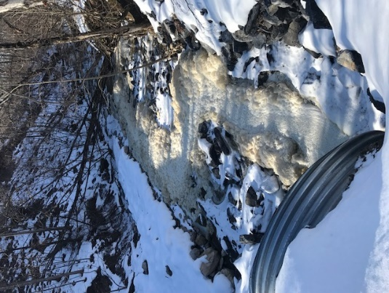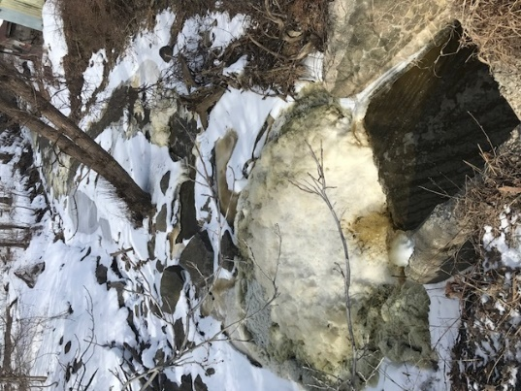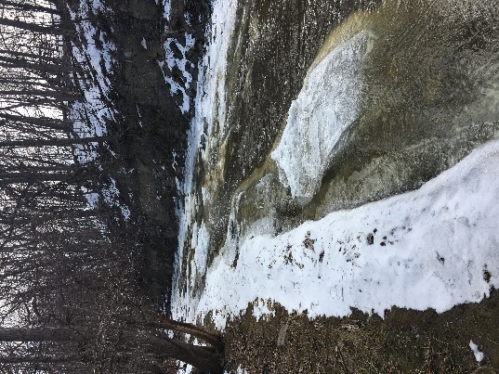
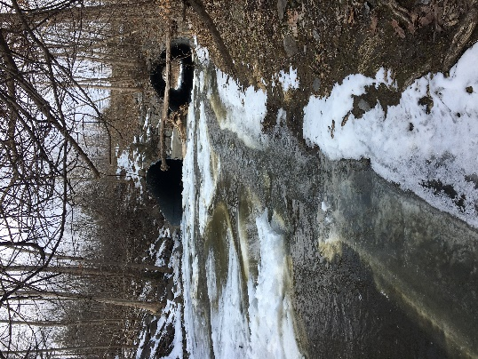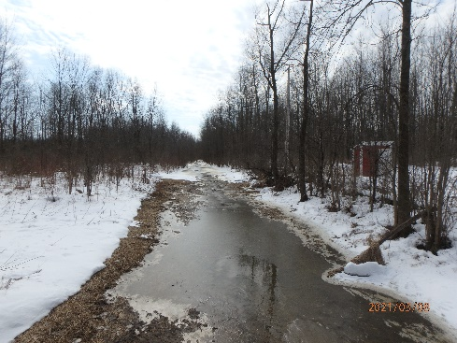

TP and SRP Loading:
Loading estimates: Comparison of DEC TMDL model (Fall Creek 2013) versus CSI dataset (limited annual synoptic sampling of based and storm flows on multiple streams over many years), and Doug Haith 2012 TP calculation (Haith, et al., 2012)
- TMDL SRP: 17 tons/year; CSI SRP: 49 tons/year
- TMDL TP: 200 tons/year: CSI TP: 124 tons/year; Haith TP 2012: 98 tons/year
The discrepancy with TP and SRP loading estimates is from northern tributaries where CSI has data and DEC extrapolated. The TMDL states that DEC validated their Cayuga Lake tributary loading model by comparing model estimates of phosphorus concentrations in Fall Creek with CSI's actual measured concentrations of phosphorus in Fall Creek, and the agreement was good (Appendix B, Table B8). This is consistent with the good agreement between TMDL loading estimates and CSI loading estimates for the southern tributaries. The TMDL does not state that DEC compared model estimates of phosphorus concentrations with CSI's measured phosphorus concentrations in northern tributaries.
The TMDL and its phosphorus load reduction requirements will impact all facets of the economy for generations to come. Therefore, it is critical to get the SRP and TP loads as accurate as possible to target BMPs and optimize the effectiveness of our efforts. There is no sense, for example, in trying to reduce TP that is mostly particulate phosphorus from Fall Creek when reducing SRP in Yawger and Great Gully Creeks would actually make a difference.

- Section 5.1.1. Compare TMDL model estimates of phosphorus concentrations with CSI’s measured phosphorus concentrations in northern tributaries to refine loading estimates.
- Section 7.2: DEC should list the sources of local data that will be used to continue to improve the model.
- Section 7.2: DEC should state how often they will update the model. If a plan for this work has not been created, it should be done and included in the final TMDL.

Opportunities: This section is a loose collection of comments and thoughts

- When the TMDL is finalized, will there be new pathways to funding through that planning mechanism?
- There are many plans that come down the pipeline. For the most part, we can all agree that the scientifically driven planning process (in this case, using a TMDL) is important for guiding management decisions, and the plans themselves tend to get funded. The difficulty moving forward will be driving targeted state funding based on the recommendations within the plan.
- How, where, and when can we expect to obtain project(s) funding associated with TMDL recommendations?
- Will the watershed be positioned for direct lines of NYS funding outside of the competitive grant process?
- Are these practices also consistent with climate adaption practices?

Municipal: WWTF, MS4s, Construction General Permit and Forestry

DEC mentioned financial impacts to the Freeville WWTP during the April 19, 2021, public information session, a comment is included in the first part of this document. WWTFs in Freeville and Interlaken are both assigned a 67% reduction in the draft TMDL (Tables 9 and 10). Freeville was not contacted about permit modifications prior to release of this document. Interlaken is in the middle of a planned upgrade and was in discussion with DEC, but it is unclear if the planned upgrade will meet the requirements called for in the draft TDML.

The Ithaca Area Wastewater Treatment Facility is currently operating under a 1.0 mg/l and 40 lbs/day TP limit. The draft TMDL proposes a concentration reduction to 0.5 mg/L and maintaining the 40 lbs/day limit (page 42). The facility was not contacted about permit modifications prior to release of this document.

All 8 WWTFs in the watershed are listed for permit modifications to include weekly SRP monitoring for at least two years (page 71, Section 7.4.1). Results will be used to determine if SRP limits should be imposed on WWTFs.

Section 7.4.4 clearly states that all new discharges will require a 100% offset of phosphorus loadings. It also states that any expansion of existing discharges will require 100% offset. The heading for this section is “Accounting for Growth in the Wastewater Sector.” It seems, however, that this section will affect growth in any sector wishing to build new or connect to existing treatment facilities. The potential impact of this section should be made clearer to watershed municipalities.

- Will DEC provide new funding to offset unexpected monitoring costs for the WWTFs?
- Are there existing technologies for SRP reduction/removal for WWTFs? If so, are there costs estimates per MGD or some other way to anticipate possible budgetary needs?
- Will DEC create a new funding stream to support possible treatment updates necessitated by the TDML?
- It appears SPDES permits will be capped by this TMDL. The potential impact to rural/growing municipalities of requiring a 100% offset for additional phosphorus discharge from the wastewater sector should be made clearer through inclusion of a section on Municipal Impacts in the TMDL, or preferably, through outreach to Municipalities. The latter could be accomplished by working with CWIO to host information sessions.
- Page 32, Section 4.1.5.1 states the eight permitted municipal wastewater treatment plants and one industrial facility are included in the TMDL because they likely have the greatest impact on Cayuga lake water quality. Page 42, Section 6.3 says the four permitted WWTFs and LSC comprise 21.8% of the annual TP load to the southern end segment of the lake. Page 71, Section 7.4 says the point source contributions (Wastewater Sector) were found to be small relative to nonpoint sources. Page 71, Section 7.4.2 says LSC contributes 0.5% of the TP annual load to the lake. Please clarify if the Wastewater sector is a small or significant contributor. Please confirm the number 21.3% (the sum of 21.8% provided in Section 6.3 minus 0.5% provided for LSC in Section 7.4.2) for the southern end WWTFs. Please address how inputs of TP to the southern segment of the lake are different than inputs to the whole lake as the southern end mixes with the whole lake every 1+ days (on average) and inputs to any 1 section of the lake are still inputs to the whole lake?
Addressing Mid-term Priority 1 BMP #5, section 7.2, page 68:
- Implement a comprehensive municipal stormwater program, including hydraulic evaluation and mapping of drainage, as well as the replacement and upgrade of subsurface resources. This project is envisioned to be a collaborative effort among SWCDs and municipalities in the Cayuga Lake watershed.
  - It is unclear if DEC means for this to apply to the entire watershed, though that is what appears to be indicated. This is a massive undertaking for both the SWCDs and municipalities. As of June 18th, 2021, municipalities and SWCDs participating in the development of these comments and CWIO meetings have not been contacted about this topic. DEC should expand on their expectations for this program and begin discussions with appropriate stakeholders before incorporating this into a regulatory document.
Tompkins County Stormwater Coalition feedback addressing the draft CL TMDL bulleted list of MCMs in section 7.5.1:
- Develop comprehensive maps of MS4 watershed and outfalls.
  - TC SWCD has grant funding and is working with 7 municipalities to map the stormwater conveyance system. The City and Town of Ithaca have already completed this mapping.
- Develop and provide public education and outreach on the sources of phosphorus (e.g., use of phosphorus-free fertilizers, leaf litter collection, proper disposal of wash water).
  - This could be completed through the Tompkins County Stormwater Coalition. The coalition has funds and could conduct/pay for education and outreach on phosphorus sources.
- Prioritize inspection of illicit discharge, detection, and elimination within area of high illicit potential, such as plant nurseries, big box stores, and other commercial businesses that may be a source of phosphorus.
  - It is not documented or apparent that this is happening in most MS4s. TC SWCD hires field mapping staff in the summer who might do some of this work. The impact of this MCM will depend on how many outfalls are prioritized as having high illicit potential.
- Prioritize inspection of construction activities.
  - TC SWCD provides construction site inspection services for the smaller municipalities on as needed basis. We typically have contracts with Danby, Caroline, Newfield, and Ulysses.
- Increase good housekeeping/pollution prevention BMPs for municipal operations and facilities, such as more frequent catch basin cleaning, street sweeping, and facility inspections.
  - It is not documented or apparent that this is happening in most MS4s.
- Incorporate, where feasible, cost-effective runoff reduction techniques and green infrastructure during planned municipal upgrades including municipal right of ways (e.g., bioswales, green streets, porous pavement, replacement of closed drainage with grass swales, replacement of the existing islands in the parking lots with bioretention or curb cuts to route the flow through below-grade infiltration areas).
  - It is not documented or apparent that this is happening in most MS4s. Projects and funding would need identified.
MS4s in the Cayuga Lake watershed are operating under an expired permit. DEC has been working on an update for several years. In the current permit, those watersheds with a TMDL for phosphorus are required to use the “Enhanced Phosphorus Removal Design Standards” in accordance with the NYS Stormwater Design Manual. There is also a requirement for a retrofit program that addresses runoff from sites to correct or reduce existing erosion and/or pollutant loading problems, with particular emphasis placed on phosphorus. Here is a link to the enhanced phosphorus removal supplement in the design manual: https://www.dec.ny.gov/docs/water_pdf/swdm2015chptr10.pdf. It can be met in a variety of ways, stormwater wetlands/ponds, infiltration/bioretention. Built/Urbanized MS4s may have to use more technological methods that require less space.
Per very recent communications with DEC (to the TC Stormwater Coalition): When the draft updated MS4 permit is released it is going to have a Chapter 8, which will be “enhanced water strategies” for watersheds without a TMDL or watersheds with a TMDL where the pollutant load is not significantly coming from MS4s. Cayuga Lake watershed is considered the latter. A possible change in the new permit will be subwatershed specific requirements, for example, different requirements for activities in Cascadilla Creek versus Cayuga Inlet.
There will be additional minimum control measures (MCMs) that must be met, but they will not be as rigorous as the requirements for NYC East of the Hudson and Onondaga Lake MS4s, which have phosphorus TMDLs where a significant amount of the load is coming from MS4s. MCMs stated in the draft Cayuga Lake TMDL (7.5.1 bulleted list, pg. 73) will be similar/close to what will be in Chapter 8 of the MS4 permit. The NYC East of the Hudson and Onondaga Lake MS4 requirements in the current permit are more stringent, because the MS4 pollutant load in the TMDL is more significant. Since this is currently not the case in the Cayuga Lake TMDL, we should not see the requirement for a retrofit program or septic system inspection program etc.
The enhanced phosphorus standard is relevant to the Construction General Permit (GP-0-20-001). The draft TMDL language in section 7.5.1, Construction Permit section, may mean that construction activities in particular areas (subwatersheds) will have to comply with the enhanced phosphorus standards.
The Construction General Permit may require enhanced phosphorus standards for some construction. While the bulk of financial impact will fall to the developer, municipalities will be required to educate developers and enforce these standards. It could also serve as a deterrent to development.
The lack of clarity in the draft TMDL language is problematic. The final wording of the TMDL will lock in compliance to some portions of the Construction General Permit and an unpublished MS4 permit update. It is impossible to comment on the unpublished MS4 permit, which also makes it impossible to comment on the TMDL implications if the TMDL is finalized prior to release of the MS4 permit.
- DEC must address possible/probable updated MS4 permit and Construction General Permit impacts more clearly in the draft TMDL so municipalities can provide meaningful comments and have some way to assess impacts on growth and budgets in their own jurisdiction.
- MS4 impacts in general have not been addressed in the public communication efforts thus far and should be addressed in a more transparent way through public hearings.
- Will DEC provide new funding support for enhanced MS4 requirements?
- The Construction General Permit may lock municipalities into new requirements based on the final TDML language. As stated in an earlier comment, the potential impact should be made clearer through inclusion of a section on Municipal Impacts in the TMDL, or preferably, through outreach to Municipalities. The latter could be accomplished by working with CWIO to host information sessions.
- Page 47 of the dTMDL states there are six municipalities in the Cayuga Lake watershed that are covered under the MS GP-15-003 (*correct permit number to GP-0-15-003), however, there are ten (10). The list does not include Tompkins County, Town of Caroline, Town of Newfield, or the Village Lansing. Please correct the permit number and the list of municipalities.
- Page 72, under 7.5.1 states that there are six municipalities in the Cayuga Lake watershed that qualify as small MS4s and are covered by GP-0-15-003. There are ten (10) municipalities that are covered by GP-0-15-003 and the municipalities listed in this section are different from those listed on page 47. This list includes the City of Ithaca, Village of Lansing, Town of Dryden, Village of Cayuga Heights, Town of Newfield, Town of Ulysses, and Town of Caroline, which totals to 7. It leaves out Tompkins County, Town of Lansing, and Town of Ithaca. Please correct the list of municipalities and clarify small, smaller, etc. designations.
- Regarding timber harvest permitting, who does/will do that? DEC said they have authority. What is DEC's plan to achieve 15% reduction? Will DEC lead on private property?
Addressing the Forestry reduction
- Slide 40 from a 2016 presentation on the Cayuga Lake TMDL, https://www.dec.ny.gov/docs/water_pdf/clmppubmtg20160309b.pdf lists practical load reduction scenarios for phosphorus based on watershed modeling as follows:
Developed land: 0-20%
Forest: no reduction
Agricultural land: 0-60%
Septic load: 0-100%
Point source: effluent limits should consider technology capabilities (0.05, 0.2, 0.8,0.1, 1.0 mg/L TP)

  - Is the 15% reduction from forested lands a later addition to the TMDL to offset the reduction set for agriculture? If not, what was the rationale for adding a forest reduction?
- Section 6.0, tables 9, 11, 12 and 14 call for a 15% reduction in forestry runoff. Section 4.1.3 on page 32 has two sentences on Forested Lands and states that TP loading consists primarily of overland runoff.
  - Please describe what is meant by overland runoff so that appropriate offsets can be considered.
- Tables 23 and 24 (pages 65-66, Section 7.2) contain nothing about forest management. The Priority 1 BMPs copied from the HABs Action Plan also do not provide forestry targeted information.
  - Please include BMPs to assist in meeting the phosphorus reduction from forested lands.
- Section 7.8.2 Forestry Conservation Practices is the only area of the TMDL that spends any time on the topic. It does not address the fact that authority over forestry practices on private property is virtually non-existent. A nice BMP field guide is referenced. SWCDs can assist willing farmers develop forestry plans through AEM. DEC is the only entity with authority over forestry activities, this is limited to State lands.
  - Is DEC assuming responsibility for the 15% reduction in forestry runoff? If not, will DEC work with municipalities to enact local laws requiring permits for private logging? Further, will DEC provide training and funding support for municipal staff to provide enforcement, or will DEC assume enforcement on private lands?

Source Water Threat:
- Section 1.2.2:
  - List all threats mentioned in Cayuga Lake’s 2004 SWAP. For phosphorus (or related) provide SWAP details.
  - List all the postulated causes for HABs from the Action Plan. It is ok to state that phosphorus inputs are one of the few (the only?) causes that can be addressed.
  - Disconnect current day HABs from a justification for the TMDL as they occurred nearly 2 decades apart or list all Finger Lakes that serve as a drinking water sources and also experience HABs as threatened/impaired and create appropriate watershed plans as required.
  - In this section and the 303d list, if necessary, remove all mention of threatened source water status related to NOM and DBPs due to lack of any supporting evidence, or provide evidence of increases and connection.
  - There are currently no local, state, or federal regulatory guidelines or requirements regarding NOM in drinking water source waters. Please remove language indicating threats to drinking water from NOM in Cayuga Lake unless some regulatory framework exists for such a statement. If so, cite and explain the regulatory framework.
Section 1.2.2 references Cayuga Lake’s 2004 SWAP without listing the specific threat related to phosphorus called out in that document.
The 2018 Action Plan is cited stating that the Mid-South and Mid-North segments of the lake are threatened as drinking water sources by algae concentrations driven primarily by external phosphorus loading. This has categorically not been established. The suspected causes of increased algal concentrations (in the form of harmful algal blooms, or HABs) include remobilization of phosphorus by zebra and quagga mussels, phosphorus inputs, and climate change variables including increasing water temperature, decreasing water pH, more periods of drought, intense storms, and increasing wind.
It appears that draft TMDL is trying to tie recent HAB occurrences in Cayuga Lake to the phosphorus TMDL. HABs were not recorded in Cayuga Lake until 2014. The Southern End segment of the lake was added to the 303d list in 1998 with phosphorus listed in 2002. Phosphorus and chlorophyll levels in the lake have been declining (this is very loosely based on Figures 8 and 9 provided in the draft TMDL) since roughly 2012. Skaneateles Lake has been recording HABs since 2017, yet it is not listed as threatened for drinking water/source water. Listing HABs as a threat to drinking water is valid. Equating Cayuga Lake HABs to an excess of nutrients is not supported by existing data.
The TMDL also attempts to link disinfection byproduct issues to an excess of nutrients in Cayuga Lake. This same attempt was made in the Action Plan. Utility data, analyzed by certified laboratories over several years, do not support the inferences made in the draft TMDL that Cayuga Lake’s NOM is threatening drinking water quality. Furthermore, a specific analysis of DBPs in drinking water from Cayuga Lake concluded that water age, not lake water quality, was the cause of DBPs (MRB Group, 2016).
There can be grave consequences in listing a use as impaired without supporting data. It is also reckless to assign the cause for a possible impairment without data. Listing, in the form of the 303(d) list, or inferring in the draft TMDL, a connection between phosphorus levels in Cayuga Lake and disinfection byproducts in finished drinking water without substantiating data would be a mistake.

Streams:
Streambank erosion and riparian corridor management BMPs are only referenced in Section 7.2 on pages 67 and 68 of the draft TMDL under Short-term priority BMPs. Methods suggested are hard armoring, natural stream design, and stream stabilization facilities. References to streambank rehabilitation and other ‘stream’ topics are covered only very generally in section 7.9. This section serves more as a background review, a list of select programs, and the value of green infrastructure than a meaningful discussion of streams in the watershed. The lack of any discussion of Cayuga Lake watershed stream conditions and more useful BMPs is unfortunate. For example, using existing dams on Six Mile Creek, trapping and dredging might be a useful BMP.
Channel migration (cutbank erosion or meander development) mostly moves the previously deposited bedload which makes up much of the cutbank alluvium. That bedload is not a major contributor of available phosphorus to Cayuga Lake, it just moves slowly downstream to the next bar.
The greater fraction of the suspended sediment load is coming from tributaries of the major streams, not the streams themselves. Main channel degradation moves up through the headwaters in the form of channel erosion and slumping (landsliding). There is no feasible way to stop some of these processes. The following images were taken in the Six Mile Creek watershed this May in the general vicinity of the X’s on the map, southwest of the City of Ithaca’s drinking water reservoir (photo credit Joe McMahon). This area has not been logged or in active agriculture in over 100 years.
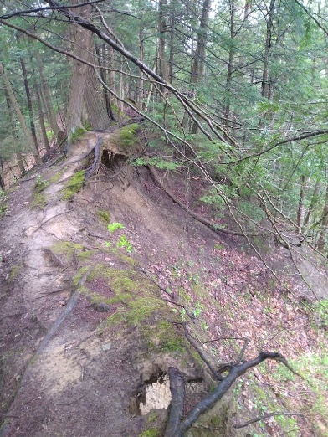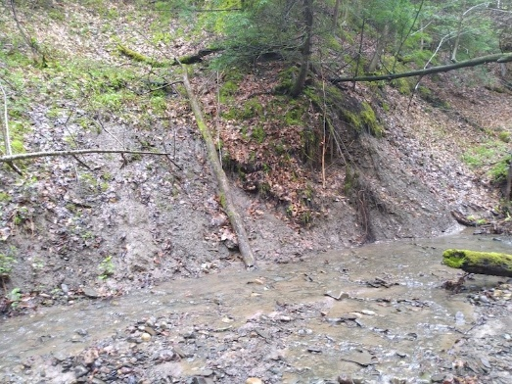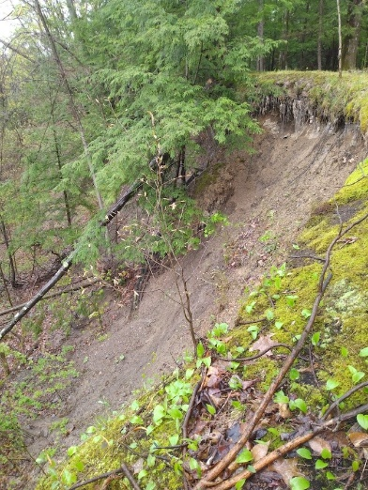
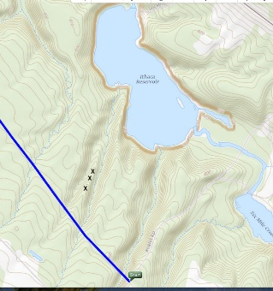
Main channel BMPs including hard armoring, plantings, fencing or even natural channel design focused on the main streams will not address ongoing process in the stream tributaries. Future main channel degradation may be lessened using weirs, etc., but potential side effects should be considered prior to implementation.
- Section 7.2: Provide specific and better suited BMPs by subwatershed, land use, and BMPs for headwaters.
- Section 7.9, Wetland and Streambank Rehabilitation introductory paragraph:
  - Review Milone and MacBroom 2005
  - Review Karig et al 2007, Sixmile Technical report
  - Read Karig 1999 (Recent channel degradation in Sixmile Creek) presented at 1999 Symposium on Environmental Research in the Cayuga Lake Watershed
  - Use the above references to create a section describing stream conditions in the Cayuga Lake watershed to help guide phosphorus reduction actions.

Wetlands:
Wetlands are listed as 4.0% of the watershed landcover. The Tompkins County Water Resources Council (WRC) has completed several studies looking at mapped and unmapped wetlands. In partnership with the Cayuga Lake Watershed Network, a consultant used the latest available data resources to conduct a wetland mapping study in 2016 and determined that there are three times more wetland area in the county than are represented on DEC or National Wetland Inventory maps. The WRC and some municipalities have adopted or regularly use the improved map to make determinations for land use, development, and protection.
The following comment was submitted to the DEC in September 2018 as part of the WRC’s review of the Cayuga Lake HABs Action Plan, and it appears that the HABs Action Plan was not updated, and the out-of-date “Priority BMP” is included in the draft TMDL: Long-term #2 addresses wetlands. It should be noted that Tompkins County has more up to date and accurate wetlands maps than available from DEC or NWI. In 2016, the Cayuga Lake Watershed Network, with financial support from the Park Foundation and Tompkins County, published Wetland Mapping for Tompkins County, New York. In total, more than 15,000 acres of wetlands were mapped. The report and link to the maps are available here: http://www.cayugalake.org/wetlands-mapping-project.html Similar mapping could be undertaken for the remainder of the watershed to provide for more targeted wetland enhancement/restoration.
- was wetland retention factored into the model?
- Section 7.2: Add adoption of the Tompkins County wetlands map to the list of Priority BMPs for use in compliance with attaining TMDL phosphorus reductions.
- Section 7.2: Add creation of similar mapping for the Cayuga Lake watershed portions of Cayuga and Seneca (and possibly Schuyler and Tioga) to the list of Priority BMPs.

References:
Effler, S. W., Matthews, D. A., Perkins, M., Johnson, D. L., Peng, F., Penn, M. R., and Auer, M. T. 2002. Patterns and impacts of inorganic tripton in Cayuga Lake. Hydrobiologia, 482(1-3), 137-150.
Effler, S. W., Prestigiacomo, A. R., Matthews, D. A., Gelda, R. K., Peng, F., Cowen, E. A., and Schweitzer, S. A. 2010. Tripton, trophic state metrics, and near-shore versus pelagic zone Page 86 of 90 responses to external loads in Cayuga Lake, New York, USA. Fundamental and Applied Limnology/Archiv für Hydrobiologie, 178(1), 1-15.

Haith, D.A., Hollingshead, N., Bell, M.L., Kreszewski, S.W., and Morey, S.J. 2012. Nutrient Loads to Cayuga Lake, New York: Watershed Modeling on a Budget. American Society of Civil Engineers. Retrieved from https://www.fcs.cornell.edu/sites/default/files/imce/site_contributor/Dept_Energy_and_Sustainability/documents/Haith%20et%20al%202012.pdf
Karig, D.E., 1999, Recent channel degradation in Sixmile Creek, in A Symposium on Environmental Research in the Cayuga Lake Watershed, NRAES-121, Cornell University.
Karig, D., Miller, T., Hackett, K., and Johnston, R., 2007, Sixmile Creek: A Status Report. Retrieved from https://hdl.handle.net/1813/8354
Li, J., Ianaiev, V., Huff, A., Zalusky, J., Ozersky, T., and Katsev, S. 2021 Benthic invaders control the phosphorus cycle in the world’s largest freshwater ecosystem. PNAS. https://www.pnas.org/content/118/6/e2008223118
Milone and MacBroom, Inc. 2005. Flood Mitigation Needs Assessment: Six Mile Creek, Salmon Creek, Fall Creek, and Cayuga Inlet, Tompkins County, New York. Retrieved from https://www2.tompkinscountyny.gov/files2/planning/water-resources/FINALREPORT.pdf
MRB Group. (revised) 2016. Preliminary Engineering Report for the Town of Ulysses. Disinfection By-Product Removal Project Water District #3. Provided by Town of Ulysses Clerk.
Nagle, G.N., Fahey, T.J., Ritchie, J.C., and Woodbury, P.B. 2007. Variations in sediment sources and yields in the Finger Lakes and Catskills regions of New York, Hydrological Processes, 21, 828-838.
New York State. 1993. Ambient Water Quality Value for Protection of Recreational Uses. Prepared by Bureau of Technical Services and Research.
Prestigiacomo, A.R., Effler, S.W., Gelda, R.K., Matthews, D.A., Auer, M.T., Downer, B.E., Kuczynski, A., and Walter, T. 2016. Apportionment of Bioavailable Phosphorus Loads Entering Cayuga Lake, New York, Journal of the American Water Resources Association. https://doi.org/10.1111/1752-1688.12366

